DESERTIfication and REGENERATION:

Modelling the impact of market reform

on central asian rangeland

Ground-based vegetation Assessment

(Work package 2, First season report)

by

Gus Gintzburger - Coordinator Work Package 2

(INRA-CIRAD – Montpellier France)

In collaboration with

Ilya I. Alimaev and Guliya Kildibekova
(Kazakhstan Research Institute of Pasture and Fodder, Almata – Kazakhstan)
and
Hodja Hanchaev, Cherkezov Atajan and Abdul Jabbar Ustad Juma
(Institute of Animal Husbandry, Ashkabat – Turkmenistan)

October 2001

Contact: Gus Gintzburger
CIRAD – ECONAP
TA 30 F – Campus de Baillarguet
34398 Montpellier Cedex 5
FRANCE
Tel + 33 (0) 467 59 39 03
Fax + 33 (0) 467 59 37 99
gustave.gintzburger@cirad.fr
www.cirad.fr or www.inra.fr

INTRODUCTION

The pastoralists of the world use native pastures and rangeland from different ecological zones at each season to maximize free forage harvesting and minimize feed storage. In Central Asia, these transhumant or nomadic systems were remodelled during the Soviet period. Kolkhozes were organized; nomadic population settled and fixed on limited grazing territories with a tight network of new wells and water points. Forage and feed was provided at high cost for the winter and drought period from remote higher rainfall or irrigated zones.
Since the fall of the Soviet system and decollectivisation of state livestock in 1991, the systematic exploitation of the rangeland collapsed, mostly due to lack of extra support and feed supply to rangeland areas. The pauperisation of the local population induced the number of animals to fall drastically and stopped livestock mobility after 1994/95. Large rangeland areas were not any more grazed. The restructuring period 1995-2000 lead to a concentration of livestock close to settlements and wells and increased fuel wood collection, inducing desertization around populated areas and regeneration of remote rangeland. After 4-5 years of reorganization at the village and region level, pastoralists and graziers are increasing their animal numbers and attempt to recolonise abandoned rangelands. They are now reconsidering seasonal livestock movement that remains the most efficient way of exploiting sparse rangeland resources. This is also to minimize external feed dependence.

The objective of our study is to monitor and detect quantifiable impacts on rangeland composition and productivity on the most important rangeland types following recent changes in livestock numbers and new flocks movement.

We will use ground-based vegetation assessment techniques to estimate vegetation cover trends and forage availability in areas exposed to potential degradation. This will involve:
- Developing reliable field methods for measuring vegetation cover trend, condition,
- Training Central Asian field staff in these methods, which they can continue to use after the conclusion of the project,
- Creating, a geo-referenced data base that will facilitate the integration of ground and remote-sensed vegetation assessments;
- Comparing, contemporary and historical data to determine land use and vegetation cover trends.

1) MatEriel and METHODS: Vegetation assessment field methods

Vegetation intercept data will be collected for each vegetation community type. A team of field workers will record intercept data on perennial plants, bare soil and rocks at ground level along a 50-100 meter measuring tape using the Line Intercept Method (LIM), a modified Canfield (1941) and CEFE (Centre d'Ecologie Fonctionnelle et Evolutive, CRNS) techniques (Daget and Poissonet 1991, Brown 1954, Gintzburger 1986). The initial purpose of this work is to document and quantify the homogeneity of the vegetation and the available biomass (annuals and perennials). Conducted over a number of seasons and years at a site accurately identified with GPS, these techniques will document changes in species composition and the prevalence of bare ground, mobile sand, as an indication of degradation or regeneration trends. We may further and refine our work with satellite imagery using the same methodology used in Australia (Caccetta et al. 2000, Karfs et al. 2000, Tongway & Hindley 1995)

The biomass of perennial plants (grasses, small and large shrubs), annuals and ephemeroids will be estimated for each vegetation type to determine if above-ground biomass and plant density are diminishing or augmenting over the study period. Up to 10 replicated measurements will be taken using quadrates. Within each sampled quadrate, species will be counted to determine their relative frequency and density, then cut at ground level, dried and weighed to determine aboveground biomass. If necessary, large quadrates will be used to sample woody perennials and relatively small quadrates will be used for annuals and ephemerals. The precise size of these quadrates will be determined by the minimum area method to ensure a representative sample area for each vegetation type (Mueller- Dombois and Ellenberg 1974).

The precise timing of sampling will be determined by plant phenology and the season of grazing, by local flocks. Standard reporting, formats will be developed to assist field staff to accurately record their observations.

The vegetations assessment field methods of annual and perennial plants are qualitative (Environment and vegetation description) and quantitative (biomass and permanent line intercept).

The environment and vegetation description includes
- Site location (GPS Coordinates)
- Geomorphology,
- Soil description (soil surface, type, colour, etc.),
- Vegetation physiognomy (type, dominant species (annual and perennials), complete plant list of scientific and local names, etc…)

1.1) Quantitative assessment of the site and the vegetation:

- Annual Plants And Ephemeroids: Evaluated by aboveground biomass measurement on one m² quadrate repeated 10 times along and spaced at 10 meters intervals (i.e. 100 meters long) along an identified and GPS located transect (Fig.1). Measurements include:
    - Above ground biomass specific contribution (g/m² DM for the dominant species or families (Graminaceae, Cyperaceae, Asteraceae, etc)
    - If possible measure specific plant density (nbr. of plants per species / m²); this is important to evaluate the level of range degradation with the density of Poa bulbosa, Carex physodes, Carex pachystylis, Bromus sp., etc …and other annual plants.

This field operation usually takes about 60-75 minutes / site for two operators working together.

- Perennial Plants:

We may use two methods:

The Line Intercept Methods (LIM) and/or

The Quadrate Method (QM)

- The Line Intercept Methods (LIM)

The Line Intercept Methods (LIM) is a modified technique from Canfield (1941). Four permanent intercept lines allowing the quantitative measurement of perennial vegetation are established on selected and representative vegetation type or sites. It gives an estimate of the measured intercept along a line of a pre-defined length.

The four permanent intercept lines radiating towards North, East, South and West, from a GPs located central point (Fig. 2) are established and monitored at least once a year, at the end of the summer or in autumn.

Each Intercept (Fig. 3) consists of a 50 to 100 meter long transect materialized by a simple rope. The intercept of the projection of each perennial plant (species 1, species 2, species 3, …. , species x) along the transect of a known length (usually 50 to 100m each) is measured and recorded on a form.

This field operation usually takes about an hour / site for three operators working together (One measuring along the rope, one recording on the form, one helping to move and place the rope).

Expected results
The % Perennial Vegetation Intercept (PVI) for each species (% PVI of species 1, % PVI of species 2, % PVI of species 3, …….., % PVI of species X ) is then calculated for each transect and sites according to the following procedure:

% PVI of species 1 = ((1.1+1.2+1.3+1.4+…+1.a) / (Length A-B)) * 100 = % PVI 1
+ % PVI of species 2 = ((2.1+…+2.b) / (Length A-B)) * 100 = % PVI 2
+ % PVI of species 3 = ((3.1+3.2+3.3+…+3.c) / (Length A-B)) * 100 = % PVI 3
+ ……………………………………………………………………………………………………………………………
+ …………………………………………………………………………………………………………………………….
+ % PVI of species X = ((X.1+X.2+X.3+…+X.m) / (Length A-B)) * 100 =% PVI m
______________________________________________________________________________________

= %TOTAL PERENNIAL VEGETATION INTERCEPT = Σ % PVI (1,2,3,…, m)

The perennial species occurrence (a = occurrence of plant 1, b = occurrence of plant 2, c = occurrence of plant 3, …, m = occurrence of plant X) is the number of time the perennial plant species 1, 2, 3 …, or m is recorded on each transect line of a known length.

The species frequency is the percentage of occurrence of a specific perennial plant (a, b, c, …, m) relative to the total number of occurrence(a+b+c+….+m) of all perennial plants species (1, 2, 3, …, X) recorded on each transect. The total of the perennial species frequency must be equal to 100%.

The perennial species frequency is calculated as follows:

Frequency of plant 1 = (a/(a+b+c+….+m)) *100),

Frequency of plant 2 = (b/(a+b+c+….+m)) *100),
-----------------------------------------------------------------

Frequency of plant X = (m/(a+b+c+….+m)) *100)

Seasonal Measurement are carried out for:
- Annual plants: at the peak standing biomass season, usually at the end of the spring when the annuals are drying out.
- Perennial plants: at the end of the growing season, usually at the end of the summer.

- The Quadrate Method (QM) is used when we encounter low or small perennial vegetation (Artemisia sp, Eurotia sp, Salsola sp. etc).

It is a combination of the Line Intercept Method and of the aboveground biomass measurement for small perennial plants when the harvesting of all perennial plants is bulky and cumbersome.

The measurement is carried out on a rectangular quadrate to minimize vegetation heterogeneity. The size of the quadrate is 2 meters wide by up to 20-25 m long (Fig. 4) delimited by four pegs linked with a rope and located in a homogeneous vegetation type. The width of the quadrate must be narrow enough to facilitate the counting of all the perennial shrubs inside the quadrate. Note that plants that are on the edge/limit of the quadrate are also counted as part of the quadrate.

Expected results
- The Specific Plant Density (“o” for the species 1, “p” for the species 2, etc) is estimated by counting the number of perennial plants (ex: Plant 1 = Artemisia sp, plant 2=Eurotia sp, etc) within the quadrate. The Specific Plant Density of plant 1 (SPD1) is then calculated and reported a “number of plant 1 / unit of area (m² or ha). The same procedure is used for all other plants (2,, etc).
- Along the length (2 x 25m in our example) of the quadrate and on the rope materializing the length of the quadrate, we are proceeding to:
  - the LIM which gives us the % PVI, Occurrence, Frequency relative to other species of each species and the %Total Perennial Vegetation Intercept,
  - the measurement of each individual dominant shrub intercepting the length of the quadrate (D1 = maximum diameter, D2 minimum diameter, H = height of the shrub),
  - then all shrubs intercepting the length of the quadrate is harvested at soil level and packed in a separate paper bag on which we mark the recorded value : D1, D2, H for the harvested shrub. Back to the laboratory, the green parts and woody parts of each individual shrub is the separated, dried and weighted individually and carefully with precision (to the mg). Dry matter collected and sorted must be kept in their original paper bags for further checking and plants analysis if necessary.
- From this data, we will obtain the average dimension (to compute the Biovolume (spheroid model) and Woody, Green and Total biomass (G+W) of the dominant shrub 1). It must be noted that the ratio (Green parts / Green parts + Woody parts) gives an indication of the condition of the range and the use of plant species.
- It is then easy to calculate from these information,
    - The estimated Specific Plant Cover of plant 1 or of any perennial plants = (Specific Plant Density (SPD) * mean soil projection of each plant (computed from Mean D1 and D2)) / total area of the quadrate (2x25 m²),
    - The Estimated Plant Biomass of plant 1 / ha = ((Mean WOODY biomass of plant 1 + Mean GREEN Biomass of plant 1) * Specific Plant Density of plant 1 (SPD1) /ha. The same procedure is applied for the other perennials present on the quadrate.

This field operation usually takes about 75 – 90 minutes / site for a three operators team.

1.2) Selection of vegetation monitoring sites

After having thoroughly done your homework (Topographical, vegetation, soil, climate, etc. maps checking), you will reach the area where you are requested to work.
When you get first to the area, spend enough days to travel and check the area. You must ask to get away from the usual / traditional camp sites – wells (and standard “guided tour” for official visitors!) and search for areas which have little or no grazing.

Do not hesitate to go cross-country and check the vegetation along transects across usual tracks and roads. This is to have a broad idea of the vegetation (absolute and relative) condition of the area. For this, you must get a 4x4 vehicle in good condition and properly equipped, and with a driver who knows how to use his vehicle in difficult cross-country condition.
If possible, find a guide who is from the area, who is willing and have time to go cross-country, who knows who, where and when the people are grazing, who knows also about wood collection for fuel and the local name and use of the vegetation. Do not hesitate to double-check the information you are given, local and Latin name for plants and sites. Collect plant specimen for a work herbarium and for proper plant identification.

Finally and whenever possible, do use a GPS for all your navigation and monitoring site location; keep track on your GPS using the tracking option of your GPS III plus / GARMIN®. Report all sites and trail/tracks on the base maps from MAPSOURCE® GARMIN for future visits.

The guiding principle:
Water is essential to livestock in arid environment and especially to small ruminant. Any flock of small ruminant need to be watered nearly every day. Small ruminant will only walk to a maximum of 4-6 km away from the well every day, therefore they will graze within 5-6 km around a given well. This is why we do expect a gradient of vegetation degradation (grazing-gradient) around wells, the most degraded area being close to the well, the range in fair to good condition being seen about 5-6 km from the well and further. Shepherd will also collect the wood of perennial plants around the well and villages where they are settled adding to the desertization of the area
During the Soviet era, a network of wells was establishes at 10-15 km intervals. This is very clear south of Ravnina in Turkmenistan (Fig. 5) and south of Malye Kamkalye in Kazakhstan (Fig. 6).

Here are general principles that guide the selection of vegetation monitoring sites for our project.
We are trying to establish a vegetation-monitoring site (Fig. 7)
- close to the well (within 300-500 m),
- at the limit of the grazing territory of each well (some 4-6 km from the well – i.e. midway between two wells),
- at the barycentre of adjacent wells and/or on remote areas where we have been told by the shepherd that no grazing is occurring.

Adapting these principles to specific condition

  - Where to place the monitoring site?

Discuss and get information from the shepherds, hunters, etc. about the currently used grazing territory (frequency, dates, intensity, Grazing tracks, fuel wood collecting sites, etc?).

  - When are we operating the LIM, the QM, or the annual biomass measurement?
    - Obviously, near the well we are mostly monitoring the annual plants (specific biomass, plant – density, floristic composition, etc) as perennials have been eradicated by overgrazing and fuel wood collection.
    - Far away from wells, we are monitoring in priority the perennials plants using the Line Intercept Methods (LIM), the Quadrate Measurement and measuring the annuals if necessary and when their contribution is important according to shepherd’s information. The floristic composition of the annuals is important; the biomass of the annuals could be similar to the one near the wells but with a different species composition.

  - Soil condition?
    - When surface with bare soil (wind or water erosion), loose sand (dunes) or rocks are important on site, record also their line intercept on the four transects-intercepts. This will give you a percentage intercept of soil condition over the years with an indication of increasing or decreasing vegetation intercept, indicating vegetation colonization or degradation related to grazing pressure or fuel wood collection.

2) THE Monitoring sites

2.1) Kazakhstan

The area designated for our study in between Malyye-Kamkaly along the Chu River (See Fig 6 - map) west of the Balkhash Lake and in the hills and low mountains between Almata and Bishkek

2.1.1) Climate

It is extremely harsh (see fig 7 – Climatogram Malyye-Kamkaly).

The mean annual precipitation is about 170 mm with extreme from 21 mm to 327 mm (Arid Mediterranean climate with extremely cold winter). As the precipitations are mostly falling during the winter-Spring period, this is still part of the extreme eastern Mediterranean climate.
The temperature may oscillate between -40°C during January and climb to + 46 in July during the 1956 – 1977 climatic period with a daily mean of the coldest month of -11°C and a daily average of the hottest month of +26.5 °C. The average number of days without frost is about 140-160.

A constant wind of an average speed of 2.5-3.5 m/sec blows all the year round, on the country that is mostly flat. It usually comes from the East in March-April, and September-November, and from the North West for the rest of the year.

2.1.2) Geomorphology, soil and Vegetation (Table 1 & 2)

- The Malyye–Kamkaly village (Jambilskaya Oblast (sites 1-7)) is located both sides of the Chu River on one of the high terrace, close to one of the large lakes that patches the landscape along the river. In the mid 80, the village was the centre of a large kolkhoz covering over 1 M ha with some 2000 inhabitants, 42500 sheep, 470 camels, 1280 horses and some 300 cattle; Gradually, the grazing and livestock activities stopped after 1991. With only about 250 inhabitants left (about 50 families), the livestock activities and range grazing are now being resuscitated, by a few very active persons from the village.

We placed our first monitoring sites on the loamy terraces between the village and the river (Sites 1-3) and then moved onto the new ranges (Sites 4-7) exploited south of the river on the sandy country that has been abandoned for 4-5 years with little grazing. Livestock owners from Malyye-Kamkaly are now recolonizing it.

- Sites 1-3: The country is hilly, gently rolling along the high terraces north of the “Chu” river. The soils are generally brown, loamy or sandy loam often covered with black gravel – or slates - stones cover, with alluvial – colluvial or detritic material. These soils are often showing strong traces of cryoturbation (alternating period of frost and soil defrosting inducing vertical soil particles movement in the very upper layers of the soil profile – soil frozen during an average 200-220 days /year).

The main vegetation for the sites 1-3 is a low chamaephytic steppe with the following dominant and most common species:

Perennials:
- Anabasis salsa (C.A.Mey) Benth ex Volkens (Ежовник солончаковый. Биюргун (Каз.)),
- Nanophyton erinaceum (Pall.) Bge. (Нанофитон ежевый.Тас биюргун (Каз.)),
- Artemisia terrae-albae Krasch. (Полынь белоземельная.Тамыр жусан (Каз.)),
- Artemisia turanica Krasch. (Полынь туранская.Туран жусан (Каз.)),
- Salsola laricifolia Turcz.,
- Salsola arbusculaeformis Drob.(Солянка лиственницелистная. Боялыш (Каз.)),
- Astragalus trifoliatus Pavl.(Жинишке сабак (Каз.)),
- Allium caesium Schrenk. (Лук синеголубой. Кокшiл жуа (Каз.)),
- Allium palassi Murr. (Лук Палласа.Паллас жуа (Каз.)),
- Сamforosma monspeliacum L. (Камфоросма марсельская. Караматау (Каз.)),
- Euphorbia rapulum Kaz.et Kir.(Молочай репка. Суттiген репа (Каз.)),
- Oedibasis apiculata Kaz. et Kir.X.-Pol.(Ойдибазис остроконечный),
- Poa balbosa L.(Мятлик луковичный. Копырбас (Каз.)),
- Potentilla songorica L.B ge. (Лапчатка джунгарская. Жонгар казтабан (Каз.)),
- Rinopetalum karelini Fisch. (Ринопеталум Карелин (Каз.)),
- Tulipa Behmiana R gl. (Тюльпан Бема. Кызгалдак Бем (Каз.)),
- Tulipa dasystemon R gl. (Кызгалдак жалгантуктi (Каз.)).

Biennials and annuals:
- Ceratocephalus orthoceras DC. (Рогоглавник пряморогий.Муйiздi шонгебас (Каз.)),
- Eremopyrum orientale (L.) (Мортук восточный. Мортук (Каз.)),
- Alyssum dasycarpum Steph. (Бурачок пушистоплодный. Тукжемiс жауылша (Каз.)),
- Bromus tectorum L.(Костер кровельный. Таракбоз арпаган (Каз.),
- Erissimum diffusum Ehrh (Шашынкы акбаскурай (Каз.)),
- Eragrostis minor Host. (E. poasoides Beamv.),
- Gagea Bergii Litv. (Гусиный лук. Казжуа Берг (Каз.)),
- Litvinovia tennuissima (Pall) Woronow. (Назiк Литвинов (Каз.)).

- Sites 4-7: The main vegetation for these sites 4-7 is on fixed and low (6-10 m) sand dunes mostly covered with small trees – nanophanerophytes (2-3 m) and high bushes, also some large open flat sandy areas covered with chamaephytic vegetation on brown sierozem and deep sandy soils; In brief, the following dominant and most common species are:

PERENNIALS:
- Haloxylon aphyllum (Minkv.) (Черный саксаул. Кара сексеул (Каз.)),
- Calligonum aphillum Pall. (Жузгун безлистный. Кызыл жузгiн (Каз.)),
- Poa bulbosa L. (Мятлик луковичный. Копырбас (Каз.)),
- Carex physodes M.B. (Осока вздутоплодная. Кияколен урмежемис (Каз.)).
- Agropyron sibiricum A.fragile. Nevski (Житняк сибирский. Кум еркек (Каз.)),
- Allium Schuberti (Лук Шуберта.У жуа (Каз.)),
- Astragalus brachypus Schrenk (Aстрагал. Актаспа (Каз.)),
- Artemisia terrae-albae Krasch. (Полынь белоземельная. Тамыр жусан (Каз.)),
- Kockia prostrata L. (Кохия простертая. Изен (Каз.)),
- Eurotia Ewersmanniana rub.(Терескен Эверсмана. (Терiскен Эверсман (Каз.)),
- Tulipa Behmiana Rg l. (Тюльпан Бема. Кызгалдак Бем (Каз.)),
- Tulipa Biflora Pall. (Тюльпан двухцветковый. Кызгалдак косгулдi (Каз.)),
- Ferula schair Borszcz.(Шайыр сасыр (Каз.)),
- Ferula assa foetida L. (Ферула вонючая. Сасык курай (Каз.)),
- Astragalus balchfschensis L.(Балхаш астрагал (Каз.)),
- Acantophyllum pungens B gell Bouss. (Тiкiнектi бозтiкен (Каз.)),
- Oedibasis apiculata Kaz.et Kir. K.o Pol. (Ойдибазис остроконечный. Ушкiр ойдибазис (Каз.)),
- Trigonella orthoceras Kaz. et Kir. (Пажитник пряморогий. Тiкендi бойдана (Каз.)),

BIENNIALS AND ANNUALS:
- Artemisia scoparia Waldst.et Kit (Полынь метельчатая. Шагр жусан (Каз.)),
- Alyssum desertorum Steph. (Бурачок пустынный. Шол жаулша (Каз.)),
- Bromus tectorum L.(Костер кровельный. Тарак бозапарган (Каз.)),
- Gagea Bergii Litv.(Гусиный лук. Казжуа Берг (Каз.)),
- Ceratocephalus orthoceras D.C. (Рогоглавник. Муйiздi шонгебас (Каз.)),
- Ceratocarpus arenarius D.C.(Рогач песчаный, эбелек. Темир ткен (Каз.)),
- Delphinium rugylosum Boiss. (Живокость мелкоморщинистая. Тегеурiпгул туысы катпарлы (Каз.)),
- Meniocus linifolius Steph.(Зыгыр жалпак (Каз.)).

The characteristics of this monitored sites are presented in table 1:

Table 1: Jambilskaya Oblast (Monitoring sites KZK-MKL 1-7)
Site Nbr | Name of site | Type of monitoring | Monitoring  Date | Dominant species  and Vegetation type | Soil type and condition | Dominant plants on site | Grazing condition | Other remarks

On the loamy –sandy loam terraces North of the Chu river near Malyye Kamkaly

KZK-MKL 1 | Karabuget  N 44 37.503  E 72 3.881 | Line Intercept Measurement | 19 April 2001 | Low shrubs (15-50 cm) - Chamaephytes  - Ceratoides papposa;  - Alhagi pseudoalhagi  - Iris casatic;  - Kochia prostrata  - Artemisia terrae-albae  - Stipa capillata | Sand, gently rolling country, Fixed low dunes, without trace of wind erosion | - Ceratoides papposa  - Stipa capillata  - Astragalus brachypus. | Moderate (limited number of sheep) | Moderatly grazed for the last 7 years. Abandoned “kachar”.
KZK-MKL 2 | Malyye Kamkaly  N 43 37.140  E 71 28.321 | Line Intercept Measurement | 20 April 2001 | Low shrubs (15-50 cm) - Chamaephytes  - Anabasis salsa;  - Artemisia turanica | Brown, Loam (Sandy-loam) with gravel and slates, rocks, some hard pan on hills, Colluvial and detritic deposit. | - Anabasis salsa,  - Artemisia turanica | Moderate in spring | Livestock (Sheep, goats, some camels, horses and cattle) graze on this site in the morning going down to Chu river lower terraces and flood-land and in the evening when coming back to aul
KZK-MKL 3 | Malyye Kamkaly  N 44 43.568  E 71 29.679 | Line Intercept Measurement,  & Annual Biomass | 20 April 2001 | Low shrubs (15-50 cm) - Chameaphytes  - Salsola laricifolia,  - Artemisia terrae albae,  - Anabasis salsa | Brown, Loam (Sandy-loam) with gravel and slates, rocks, some hard pan on hills, Colluvial and detritic deposit. | - Salsola laricifolia,  - Artemisia terrae albae | Moderate in spring | Livestock graze on this site in the morning going down to Chu river lower terraces and flood-land and in the evening when coming back to aul
On sandy – fixed sand dunes (South of the Chu River) / Moyinkum Sand
KZK-MKL 4 | Bazarkhan (1,5 km from winter house)  N 44 17.076  E 71 35.333 | Line Intercept Measurement | 21 April 2001 | Big shrubs – Nanophanerophytes (2-3 m)  - Calligonum aphillum;  - Kochia prostrata  - Aristida penata,  - Astragalus balchaschensis  - Ceratoides papposa;  - Haloxylon aphillum,  - Agropyrum desertorum | Fixed sand dunes, deep sand, no trace of wind erosion | - Calligonum aphillum,  - Kochia prostrata,  - Haloxylon aphyllum | Moderate | Livestock moved to other sites from April until November; pastures recover well from rest
KZK-MKL 5 | Kazbek (near winter house)  N 44 11.077  E 71 41.301 | Line Intercept Measurement | 21 April 2001 | Big shrubs – Nanophanerophytes (2-3 m)  - Haloxylon aphyllum,  - Carex physoides,  - Agropyrum desertorum,  - Calligonum aphyllum,  - Ceretoides papposa,  - Artemisia terrae albae | Fixed sand dunes, deep sand, no trace of wind erosion | - Haloxylon aphyllum,  - Calligonum aphillum,  - Ceratoides papposa | Moderate | Livestock moved to summer pastures from March until November
KZK-MKL 6 | Kazbek (summer house)  N 44 16.862  E 71 44.067 | Line Intercept Measurement | 22 April 2001 | Low shrubs (15-50 cm) - Chamaephytes  - Ceratoides papposa;  - Artemisia terrae albae;  - Kochia prostrata;  - Salsola orientalis;  - Astragalus balchaschensis | Loamy-sand, Fixed sand dunes, deep sand, no trace of wind erosion | - Artemisia terrae- albae,  - Kochia prostrata | Moderate | Livestock grazing there from March until November
KZK-MKL 7 | Kazbek (6 km North from summer Camp)  N 44 19.579  E 71 43.501 | Line Intercept Measurement | 22 April 2001 | Low shrubs (15-50 cm) - Chamaephytes  - Artemisia terrae albae,  - Kochia prostrata,  - Ceratoides papposa,  - Salsola orientalis | Loamy-sand, Fixed sand dunes, deep sand, no trace of wind erosion | - Artemisia terrae albae,  - Ceratoides papposa | Slightly grazed | No grazing during the last 6-7 years

The other sites (KZK-ALM 8-13) are located on the foothills close to the mountains south of the Almata – Bishkek main road in the Almatinskaya oblast (Table 2).

Table 2: Almatinskaya oblast (Monitoring sites KZK-ALM 8-13)

Site  Nbr | Name  of site | Type  of  Monitoring | Monitoring  Date | Dominant species  and  Vegetation type | Soil type  And  Condition | Dominant plants  on  site | Grazing  condition | Other remarks
KZK-ALM 8 | Aidarly  (1 km from aul)  N 44 11.066  E 75 49.774 | Line Intercept Measurement, Annual Biomass | 10 July 2001 | - Artemisia terrae albae,  - Peganum garmala | Sandy loam sierozem, erosion manifestation | - Peganum harmala | Overgrazed | Permanent grazing all year round
KZK-ALM 9 | Aidarly  (15 km from aul)  N 44 07.926  E 75 48.480 | Line Intercept Measurement, Annual Biomass | 11 July 2001 | - Artemisia terrae albae | Sandy loam sierozem | - Artemisia terrae albae | Slightly grazed | No grazing for the last 5-6 years
KZK-ALM 10 | Ulguly  (1 km from aul)  N 43 26.260  E 76 06.100 | Line Intercept Measurement, Annual Biomass | 12 July 2001 | - Artemisia lessingi,  - Kochia prostrata,  - Stipa lessingi,  - Carex physodes,  - Colpodium sp. | Sierozem without erosion | - Artemisia lessingi | Moderate grazing | Livestock moved to summer pastures
KZK-ALM 11 | Ulguly  (5 km from aul)  N 43 26.310  E 76 03.730 | Line Intercept Measurement, Annual Biomass | 13 July 2001 | - Artemisia lessingi,  - Poa bulbosa,  - Stipa capillata,  - Carex physodes,  - Lappula scuarrosa | Sierozem | - Stipa capillata,  - Artemisia lessingi | Slightly grazed | No grazing for 4-5 years
KZK-ALM 12 | Shien  (0,5 km from aul)  N 43 11.540  E 75 54.190 | Line Intercept Measurement, Annual Biomass | 14 July 2001 | - Artemisia lessingi,  - Kochia prostrata,  - Poa balbosa,  - Carex physodes | Sierozem | - Artemisia lessingi | Moderate grazing | Permanent grazing
KZK-ALM 13 | Shien  (5 km from aul)  N 43 09.720  E 75 51.410 | Line Intercept Measurement, Annual Biomass | 15 July 2001 | - Stipa capillata,  - Festuca valesiana,  - Poa bulbosa,  - Carex physodes | Light chestnut, without erosion indication | - Stipa capillata,  - Festuca valesiana | Slightly grazed | No grazing for the last 4-5 years

2.2) TURKMENISTAN

The assigned site of survey are in the Ravnina region about 85 Km North East of Mary, and in the Gök Tepe region some 20-70 km north West of Ashkabat.

2.2.2) Geomorphology, soil and vegetation (Table 3,4 & 5)

The whole area is sandy, mostly with high (10-30 m) fixed sand dunes covered with medium height Haloxylon aphyllum (2-3m) and Astragalus unifoliatus vegetation with some place with Aristida Karelinii growing on moving sand.

All soils are deep sand.

Signs of past degradation are obvious as some areas are totally devoid of tall shrubs long collected for fuel wood. . The cover of annual plants such as Bromus tectorum and B. Danthoniae indicate an ultimate stage of overgrazing and range degradation close to the wells. Often, one can see shifting and mobile sand covering the tracks, making the

The monitored sites were chosen along transects between well in order to locate the different facies of vegetation degradation.

Table 3: RAVNINA Region in Turkmenistan (Monitoring Sites TRKM-R 1-10)

Site  Nbr | Name  of site | Type  of  Monitoring (1) | Type  of  Monitoring | Dominant species  and  Vegetation type | Soil type  And  Condition | Dominant  plants  on  site | Grazing  Condition | Other remarks
TRKM-R 1 | Seretelli N 37 40.627 E 62 34.618 | Annual Biomass,  Line intercept Measurement | 9 April 2001 | - Convolvulus divaricatus,  - Astragalus unifoliolatus  - Carex physodes | Sandy loam, loose surface, | - Carex physodes,  - Bromus tectorum,  - Cutandia memphitica | Not grazed for 3 years | Little Shrubs and perennials, near abandoned well, Degraded, mostly ephemerals
TRKM-R 2 | Between wells Sereteli  and II Yigrimibesh  N 37 38.414 E 62 37.145 | Annual biomass | 9 April 2001 | - Calligonum setosum,  - Astragalus unifoliolatus  - Carex physodes | Sandy loam, loose surface, | - Carex physodes  - Bromus tectorum,  - Poa bulbosa,  - Arnebia decumbens | Not grazed for one Year | Normal association, good condition,
TRKM-R 3 | II Yigrimibesh  N 37 35.642 E 62 39.505 | Annual biomass | 9 April 2001 | - Calligonum setosum,  - Astragalus unifoliolatus,  - Carex physodes,  - Convolvulus divaricatus | Sand, loose surface | - Bromus tectorum,  - Carex physodes,  - Bromus Danthoniae,  - Eremopyrum bonaepartis | Slightly grazed, first years | Very degraded, no perennials near well, some wind erosion
TRKM-R 4 | Between wells II and I Yigrimibesh  N 37 38.071 E 62 39.655 | Annual biomass | 10 April 2001 | - Calligonum setosum,  - Astragalus unifoliolatus  - Carex physodes,  - Poa bulbosa | Sand, loose surface | - Carex physodes  - Poa bulbosa,  - Arnebia decumbens,  - Alyssum desertorum,  - Erodium cinonium | Slightly grazed, first years | Good ephemerals vegetation and ephemeroids, many Carex physodes
TRKM-R 5 | 1 Yigrimibesh  N 37 41.370 E 62 39.606 | Annual biomass, LIM | 10 April 2001 | - Calligonum setosum,  - Convolvuls divaricatus,  - Astragalus unifoliolatus  - + Ephemerals | Sand, loose surface | - Carex physodes,  - Bromus tectorum,  - Hypecoum parviflorum,  - Arnebia decumbens,  - Cutandia memphitica | Slightly grazed | Slightly degraded
TRKM-R 6 | Between wells 1 Yigrimibesh and Tahtali-1  N 37 43.041 E 62 43.359 | Annual biomass | 10 April 2001 | - Haloxylon persicum,  - Convolvulus divaricatus,  - Astragalus unifoliolatus  - Carex physodes  - + Ephemerals | Sand, loose surface | - Carex physodes  - Bromus tectorum  - Poa bulbosa, | Slightly grazed | Not degraded, many dry shrubs
TRKM-R 7 | Tahtali-1  N 37 42.766  E 62 44.778 | Annual biomass | 10 April 2001 | - Calligonum setosum  - Convolvulus divaricatus,  - + Ephemerals | Sand, Loose surface | - Hypoceum parvilorum  - Bromus tectorum,  - Eremopyrum orientale,  - Malcolmia grandiflora,  - Isatis violascens | Slightly grazed, first years | Very degraded, no perennials near well, some wind erosion

TRKM-R 8 | Allaberen  N 37 20.773 E 63 05.811 | Annual biomass, Line Intercept Measurement | 26 May 2001 | - Calligonum eriopodium,  - Carex physodes,  - Convolvulus divaricatus  - Astragalus unifoliolatus | Sand, loose surface | - Carex physodes,  - Poa bulbosa,  - Anisantha tectorum,  - Astragalus filicaulis,  - Cousinia schistoptera. | Slightly grazed | Not degraded.
TRKM-R 9 | Between wells Allaberen and Tagta  N 37.21.308 E 63.08.687 | Annual biomass, Line Intercept Measurement | 26 May 2001 | - Calligonum eriopodium,  - Carex pachystylis,  - Poa bulbosa,  - Mausolea eriocarpa | Sand loam, Loose surface | - Poa bulbosa,  - Carex pachystylis,  - Astragalus filicaulis,  - Alyssum desertorum. | Slightly grazed | Not degraded.
TRKM-R 10 | Tagta  N 37.21.776 E 63.13.419 | Annual biomass, Line Intercept Measurement | 26 May 2001 | - Calligonum eriopodium,  - Calligonum setosum,  - Astragalus unifoliolatus  - Mausolea eriocarpa | Sand, Loose surface | - Anisantha tectorum,  - Poa bulbosa,  - Hordeum spontaneum. | Grazed | Very degraded, no Carex, no perennials near wells.
Table 4: GÖK TEPE Region in Turkmenistan (Monitoring Sites TRKM-GTP 1-5)

TRKM-GTP 1 | 1 km from Gatyduip  N 39.17.101  E 58.06.478 | Annual biomass, Line Intercept Measurement | 23 May 2001 | - Ammodendron conolli,  - Haloxylon persicum,  - Peganum harmala | Sandy | - Peganum harmala,  - Anisantha tectorum,  - Aristida Karelinii. | Grazed | Very degraded, only inedible plants.
TRKM-GTP 2 | 5 km from Gatyduip  N 39.15.179 E 58.07.048 | Annual biomass, Line Intercept Measurement | 23 May 2001 | - Calligonum rubens,  - Astragalus longipetiolatus ,  - Carex physodes | Sandy | - Carex physodes,  - Anisantha tectorum,  - Calligonum rubens | Slightly grazed | No degraded
TRKM-GTP 3 | 1 km from Dortaji  N 38.25.735 E 58.14.226 | Annual biomass, Line Intercept Measurement | 24 May 2001 | - Seriphidicum (Artemisia) cemrudicum  - Peganum harmala | Sandy loam | - Seriphidium (Artemisia) cemrudicum | Grazed | Very degraded, no annual grass.
TRKM-GTP 4 | 2,5 km from Dortaji  N 38.24.747 E 58.14.226 | Annual biomass, Line Intercept Measurement | 24 May 2001 | - Calligonum setosum,  - Salsola Richteri,  - Carex physodes,  - Artemisia sp. | Sandy loam | - Carex physodes,  - Cutandia memphetica,  - Calligonum setosum,  - Salsola Richteri,  - Anisantha tectorum Artemisia sp.. | Slightly grazed | Slightly degraded, not much annual grass.
TRKM-GTP 5 | 5 km from Gatyduip  N 38 23.297  E 58 13.518 | Annual biomass, Line Intercept Measurement | 24 May 2001 | - Calligonum setosum,  - Salsola Richteri,  - Carex physodes. | Sandy | - Carex physodes,  - Cutandia memphetica,  - Calligonum setosum,  - Salsola Richteri,  - Anisantha tectorum. | Slightly grazed | Not degraded

Table 5: TURKMENISTAN (Ravnina and Gök Tepe sites - Season 2001)

Sites  (Location , Region) | Geomorphology | Soil type | Dominant species (Latin name + Authority) | List of most frequent species  (Latin name+ Authority + local name) | Remarks
RAVNINA 1 | Peschannye pastbisha UGO-VOSTOCHNYH KARA KUMOV ,melcogriadovye bugristye pesci | Sand | Calligonum setosum Litv., Calligonum rubens Mattei, Carex physodes M.B., Aristida pennata Trin. | PERENNIALS: Calligonum setosum Litv. ( Чакыш), Calligonum rubens Mattei (Эркек гандым) , Ephedra strobilacea Bunge (Боржак ), Astragalus unifoliolatus Bunge (Синрен ), Convolvulus divaricatus Regel et Schmal.(аккерт), Carex physodes M.B.( Йылак), Aristida pennata Trin.(Уркачы селин).  ANNUALS: Anisantha tectorum (L.)Nevski (Епелек), Cutandia memphitica (Spreng) Richt.(Епелек), Bromus Danthonae Trin.(Гум суле), Eremopyrum buonopartis(Spreng) Nevski (Арпаган), Alissum desertorum Stapf.(Чапраз), Malcolmia grandiflora (Bunge) O.Kuntze (Гызыл гозалак), Isatis violascens Bunge(Гокдамак). | No Haloxylon persicum
RAVNINA 2 | Melcogriadovye bugristye zakreplennye peski v cheredobanii s holmami s izrejennymi kustarnicami | Sand, sierozem | Calligonum eriopodum Bge, Calligonum setosum Litv., Carex physodes M.B. (80%) Poa bulbosa L., Carex pachystylis Gay.(20%). |  | No Haloxylon persicum
PERENIALS: Calligonum eriopodum Bunge (Гызыл гандым), Calligonum setosum Litv.(Чакыш ), Aellenia subaphilla (G.A.Mey) Aell.(Чогон), Astragalus unifoliolatus Bunge(Синрен), Ephedra strobilacea Bunge(Боржак), Mausolea eriocarpa (Bunge) Poljak(Сыза), Carex physodes M.B.(Йылак), Carex pachystylis Gay(Гарайылак), Poa bulbosa L.(Гыртыч), Aristida pennata Trin. (Уркачы селин), Cousinia schistoptera Juz(Дурнадабан).

ANNUALS: Anisantha tectorum (L.) Nevski (Епелек), Astragalus filicaulis Fisch.et Mey.(Нохутак), Hordeum spontaneum C.Koch.(Тек-тек), Alissum desertorum Stapf (Чапраз), Lapulla semiglabra (Lebed.) Guerke.(Япышак), Arnebia decumbens (Vent.) Coss. et Krul.(Гызыл дуйп), Isatis violascens Bunge(Япыр,гокдамак), Bromus Danthoniae Trin (Гум суле), Senecio subdentatus Lebed.(Япыр).
GÖKTEPE N° 1 | Gryadovo-bugristye peski | Sand | Haloxylon persicum Bunge ex Boiss.Et Bunse., Carex physodes M.B., Aristida pennata Trin. | PERENNIALS: Haloxylon persicum Bunge ex Boiss. Et Buhse.(Ак сазак), Ammodendron conollyi Bunge (Созен), Calligonum rubens Mattei.(Эркек гандым), Calligonum setosum Litv.(Чакыш), Astragalus longipetiolatus M.Pop.(Патлак,синрен), Convolvulus Kopolkovii Bunge et Schmath.(Гум керт , печек), Carex physodes M.B.(Йылак), Aristida pennata Trin ( Уркачы селин), Aristida Karelinii Trin.et Rupr.(Эркек селин), Peganum harmala L.(Йузарлик). ANNUALS: Anisantha tectorum (L.) Nevski(Епелек), Cutandia memhitica (Spreng)Richt.(Епелек), Alissum desertorum Stapf.(Чапраз), Malcolmia grandiflora (Bunge) O.Kuntze(Гызыл гозалак), Bromus Danthonae Trin (Гум суле), Ceratcephalus falcatus Pers.(Черрик).
GÖKTEPE N°2 | Gryadovye peski v soche- tanii stakyrovidnymi poch- vami | Sandy, Loam | Calligonum setosum Litv., Salsola Richteri Karel., Carex physodes M.B., Halocnemum strobilicaeum M.B. | PERENNIALS : Calligonum setosum Litv.(Чакыш), Salsola Richteri Karel.(Черкез), Salsola arbuscula Pall. (Боялыч), Convolvulus Korolcovii Bunge et Schmath.(Гум керт), Convolvulus divaricatus Regel et Schmal.(Аккерт), Astragalus unifoliolatus Bunge (Синрен), Artemisia kemrudica Krasch.(Евшан), Ammothamnus lehmannii Bunge(Ажы буян), Carex physodes M.B. (Йылак), Aristida pennata Trin.(Уркачы селин), Salsola gemmascens (Тетир), Halocnemum strobilicaeum M.B. (Шоратан). ANNUALS: Anisantha tectorum (L.) Nevski (Ерелек), Cutandia memphitica (Spreng)Rich.(Ерелек), Isatis violascens Bunge (Гокдамак), Malcolmia grandiflora (Bunge)O.Kutze (Гызыл гозалак), Streptoloma desertorum Bge(Акгулли), Trigonella noeana Boiss. (Учяпраклыжа).

Conclusion

This year activities were mostly devoted to become familiar with the work area. Most of the work was carried out during spring and summer missions in each area to collect information on annual and ephemerals plants.

The areas to visit are remote and difficult to access in a short time. All field missions require a minimum of one full week in the field that makes a total of 11-13 days outing for each mission.

Complementary missions mostly to collect information on the status of the perennial vegetation are planned for this fall 2001.

The methodology was tested and adjusted in the field.

BIBLIOGRAPHY

- Caccetta P., Allen A. & I. Watson. 2000. The Land Monitor Project. ARSPC, Adelaide, Australia, 11p
- Canfield, R.M. 1941. Application of the line interception method in sampling range vegetation. J. Forestry. 39:388-394
- Gintzburger G. 1986. Seasonal Variation in Above-ground Annual and Perennial Phytomass of an Arid Rangeland in Libya. J. Range Manage. 39 (4): 348-353.
- Karfs R. Applegate R., Fisher R., Lynch D., Mullin D., Novelly P., Peel L., Richardson K., Thomas P. & J. Wallace. 2000. Regional Land Condition And Trend Assessment In Tropical Savanas: The Audit Rangeland Implementation Project Final Report, National Land and Water Resources Audit, Canberra, Australia. 55p
- Tongway D. & N. Hindley. 1995, Manual for soil condition assessment of Tropical Grasslands. CSIRO, Div. Of Wildlife and Ecology. Canberra. 60p

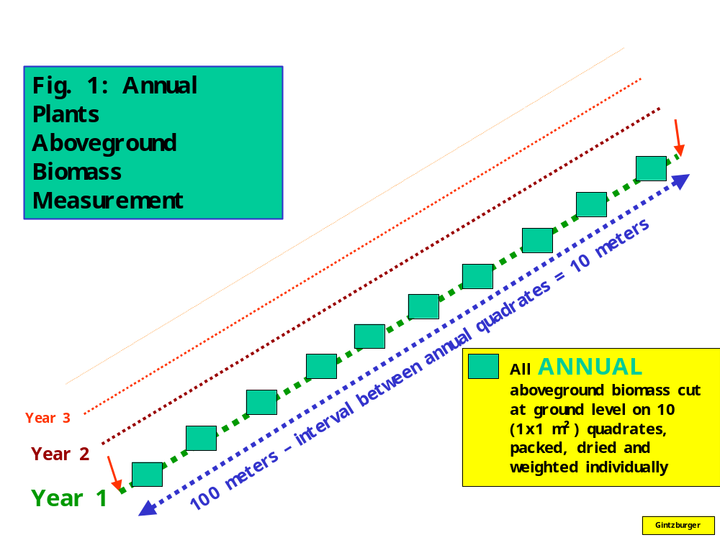

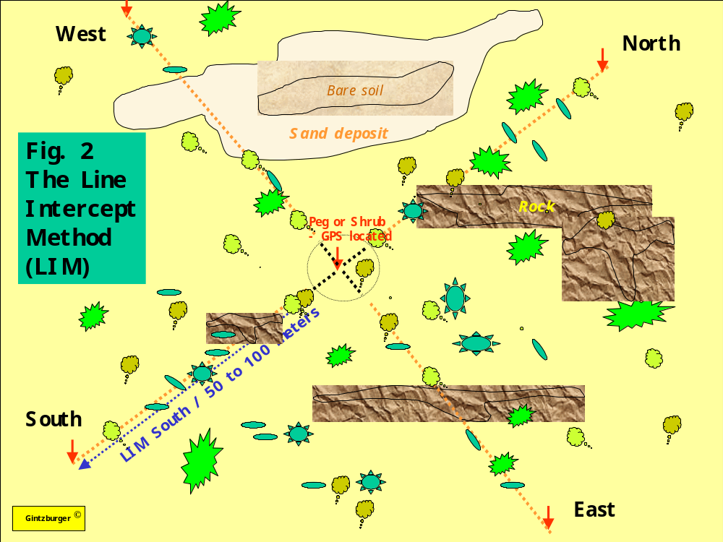
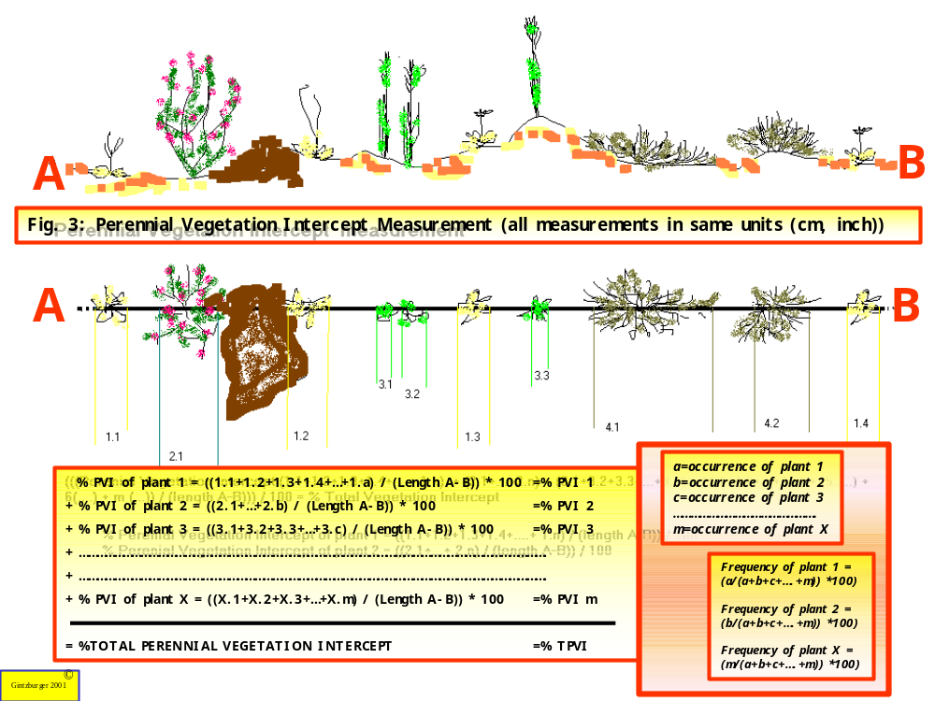

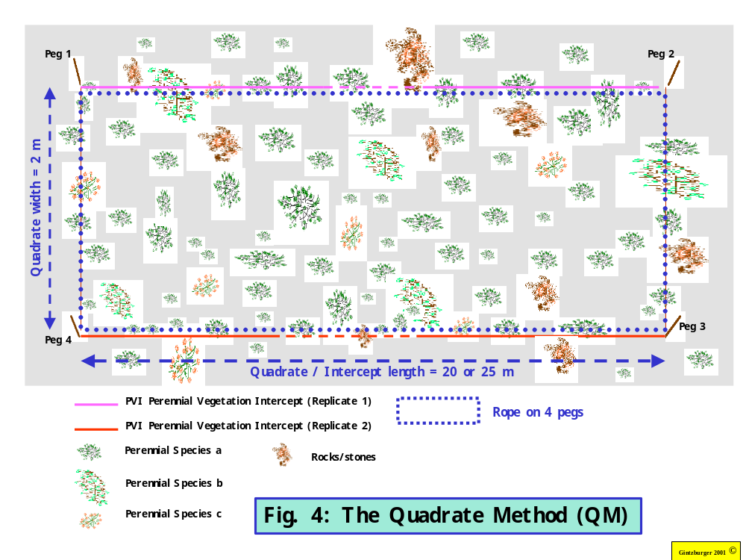
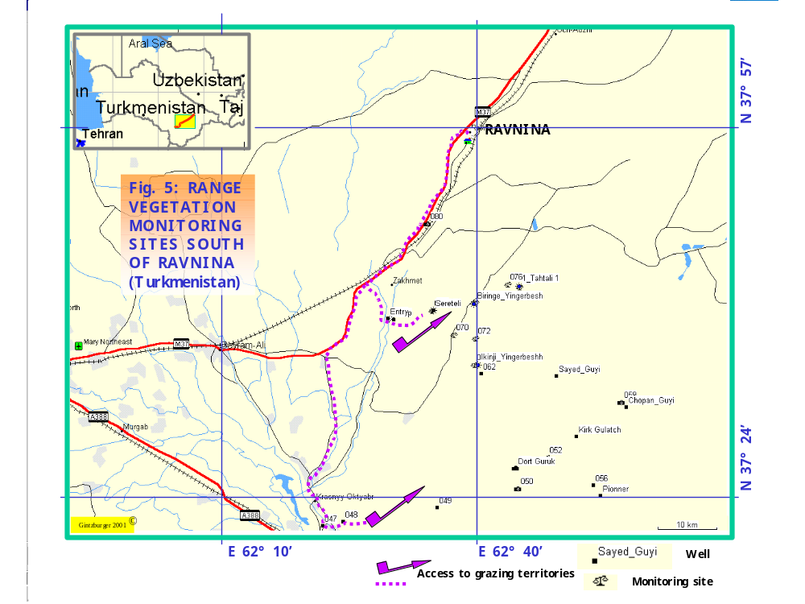
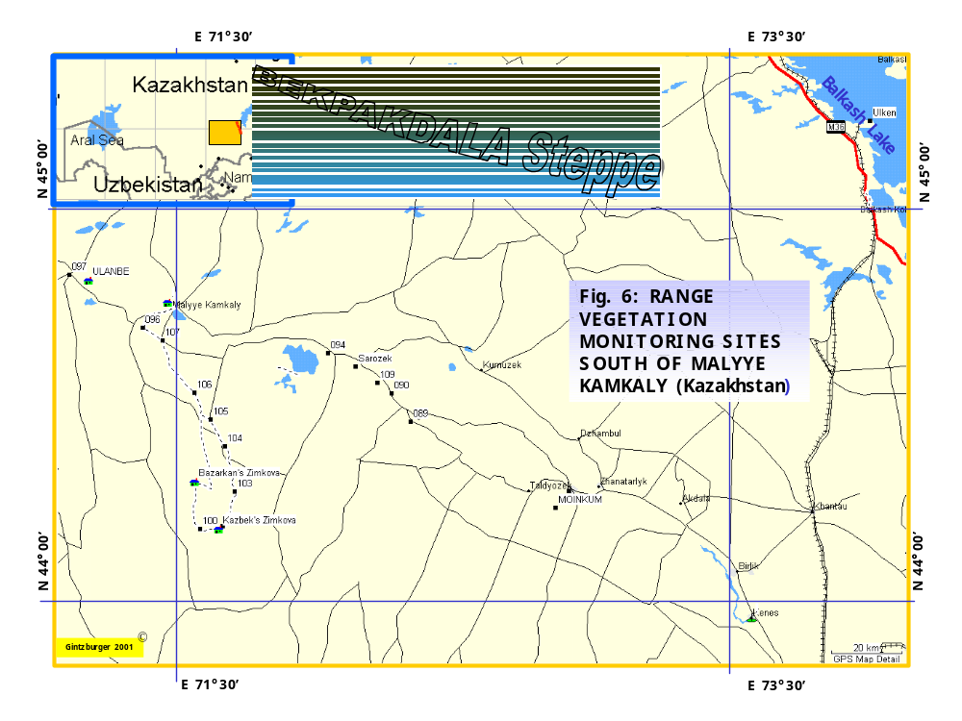
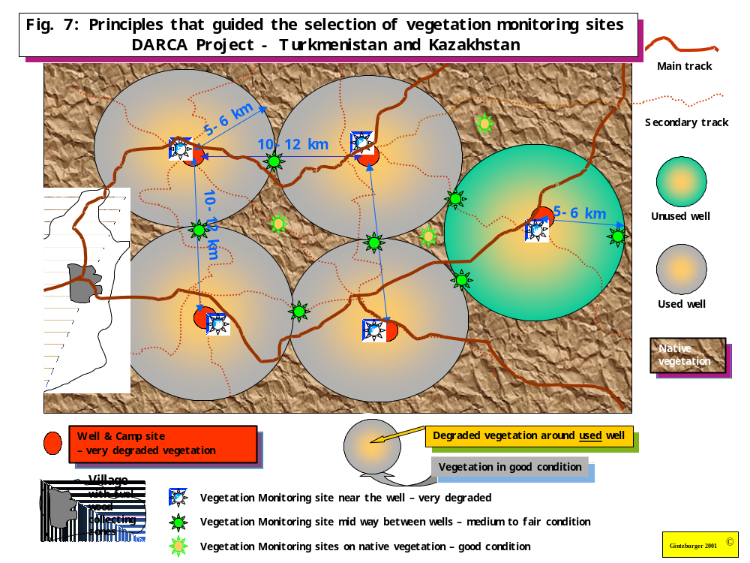

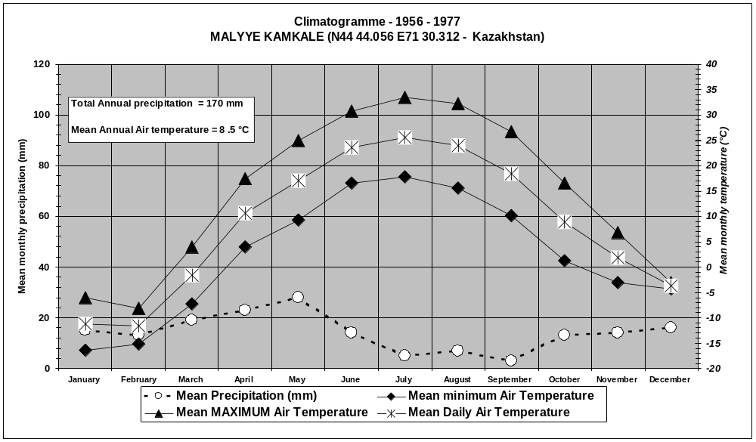

Figure 7: Climatogramme (1956-1077) from Malyye-Kamkale village in Kazakhstan.

