DARCA PROJECT: WORK PACKAGE 7

Kazakstan
Participatory video project
Phase 2
February 2002

Small World Action Projects Ltd

Chris Lunch (ed.)
Contact address: 8 Milton Court, Milton Malsor, Northampton. UK.
e-mail; clunch@hotmail.com
Kazakstan Participatory Video Project

February 2002

Contents
Abstract  Description of the film  Implementing organisation  The team  Editing in the UK  Project Aims  Timetable of activities  Working with the scientists  Working with the communities  Working with policy makers  Working with international donors  Recommendations for future work |  | Page  3  4  5  5  5  5  6  7  10  12  12  13
 | Acknowledgements: Thanks to the team members and local scientists. To Maddy, Rowan and Asher for their love and support. To Emilie Flower for her contribution towards the success of the project To all the shepherding families who participated in this project and shared their lives, warmth and hospitality with us. Also to Roy Behnke and Carol Kerven for making it all happen.

ABSTRACT

Phase 1 of the participatory video project took place in May 2001. Local scientists participated in workshops and filmed questions eliciting local knowledge on topics they were researching. Two weeks were then spent conducting workshops in Aidarly village. The team of facilitators led by Chris Lunch included 3 scientists from the institute of pasture and fodder who received training in participatory methods. The team helped villagers make their own films presenting their ideas and perspectives on important issues such as over grazing around villages, land privatisation and local ideas for increasing profits from livestock products.
In Phase 2 the completed film was shown to a number of different target audiences both in the UK and Kazakstan. It was well received by all:
- Both national TV channels wanted copies of the film. It will be broadcast to millions of rural and urban viewers.
- In the villages it stimulated discussions and enabled an exchange of ideas between shepherds in structurally similar situations.
- The regional administrators felt it supported their aims to encourage shepherds to migrate. They wanted a copy to show at an upcoming meeting of all the regions’ heads of local administration.
- International donor agencies based in Almaty welcomed the chance to hear about the DARCA project and learn about the situation in rural Kazakstan from the people themselves.
- A longer version of the film was shown at the DARCA meeting held in Aberdeen (Nov 2001), and to scientists from the institute of pasture and fodder in Almaty.
The participatory video methods proved themselves to be a powerful tool for initiating community action and for influencing policy and disseminating results. By involving the community in the process of making their own film several goals were achieved at once:
- The making of the film and the film itself, raised awareness among the local population about issues regarding emerging grazing practices.
- By enabling the villagers to propose their own solutions and ideas they became involved in the project and were given a voice in the decision making processes.
- The project has stimulated a dialogue between the villagers, local authorities, scientists, and the international donor community.
- Our work has empowered the community and weakened the mentality of hopelessness and dependency (attitudes prevalent among many rural communities in the former Soviet Union).
- Scientists from the institute of pasture and fodder are now able to use participatory video as a tool in their future work.

DISCRIPTION OF THE FILM: Filming was carried out in May 2001. Villagers filmed, directed and conducted interviews. Material was edited in the UK by Chris Lunch. The film consists of 5 short films each made by different groups of villagers.

1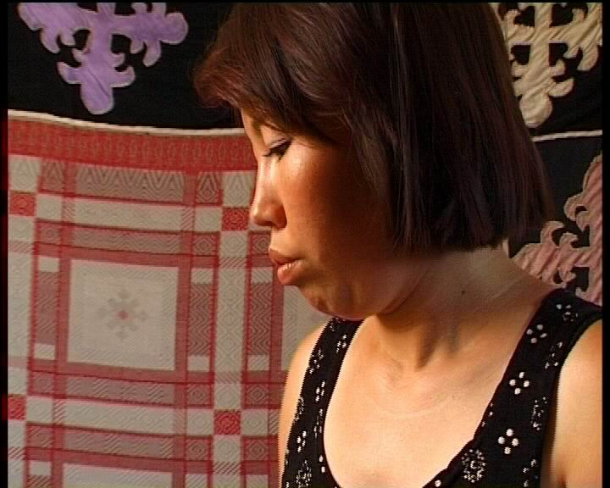  2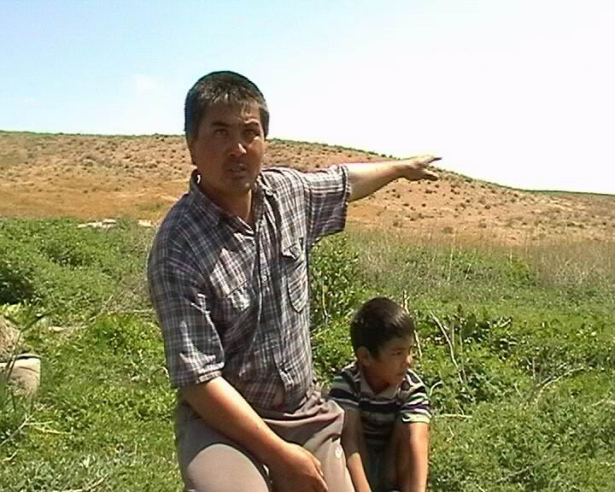  3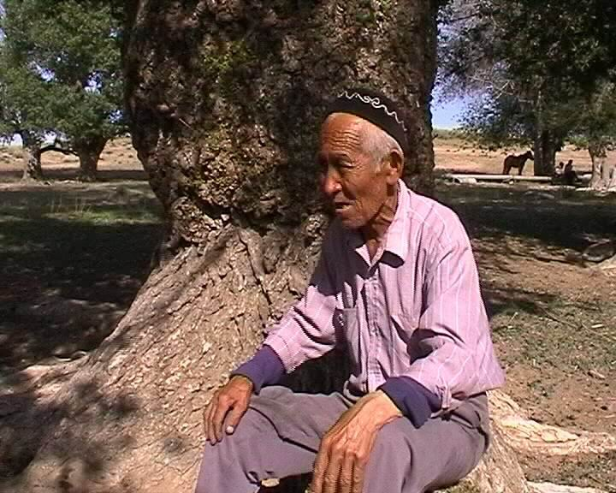  4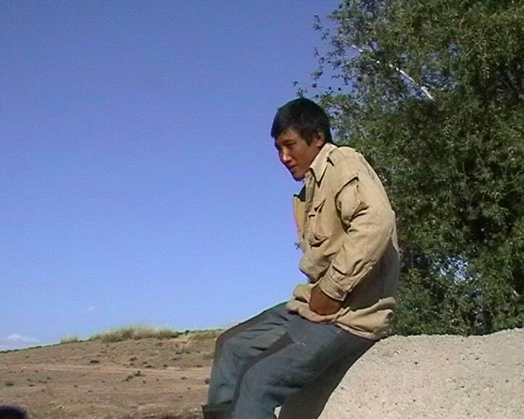  5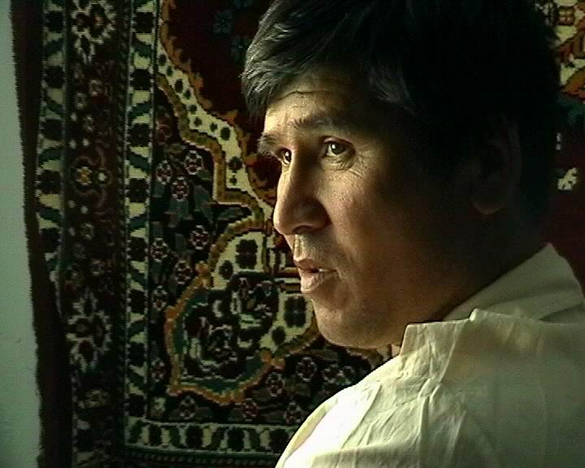 | Zhanna and her sister filmed and directed this short film called “Fresh ideas for dairy products”. The different dairy products are shown. Zhanna says they need a leader in the village to organise women into a dairy cooperative. As she outlines her own ideas and interviews some villagers about local demand she realises she could do this!  Bahit, a shepherd from Aidarly, took us to the traditional spring pastures which have not been grazed for 10 years. He and his friends plan to join their flocks and migrate to these pastures once again. They hoped their film would encourage others to do the same. This short film was called "Returning to forgotten pastures" it was planned and directed by Bahit and 3 other shepherds.  Kazy explains; “keeping sheep in the village causes pollution and the spread of disease, if the land is over-used animal will die in bad years”. He asks local administration to get people with >20 sheep to migrate. The film also looks at the higher returns experienced when shepherds join and migrate to richer pastures. "Cooperating for greater profits”; planned and directed by 4 local shepherds.  Berik is a young shepherd who plans to go to the city to work as a driver. He describes how he was selected to herd the village’s bullocks away from the village. “Herding for the village” shows a positive solution to degradation. It also describes how lack of work is forcing many (especially young people) to leave the villages.  Zharkin, a local shepherd, says "we want to move our animals out of the villages but we are insecure about our land rights. We need a lawyer who can represent us, tell us our rights and mediate in local disputes about  land". He presents his ideas in the short film “Land rights?”; planned and directed by Zharkin himself.

IMPLEMENTING ORGANISATION: Small World Action Projects Ltd. (SWAP): Founded by Chris Lunch in 1998, SWAP aims to help marginal communities increase their ability to participate in decision-making processes concerning economic, political and environmental issues. Communities are given the opportunity to take an active role in addressing local issues and concerns. Exchange of experiences, ideas and locally based solutions between communities facing similar circumstances is encouraged. We aim to introduce a process that allows the energy and initiative for change to come from within the community.

THE TEAM:
Chris Lunch: Project leader. Trained in Anthropology and participatory video. Has worked with rural communities in Central Asia since 1994.
Gulia Khardebekova: Trainee in participatory video methods. Head of chemical analysis lab at the Institute for Pasture and Fodder, Kazakstan.
Zhecksimbai Sisatov: Trainee, scientist and driver!
Aidos Smailov: Trainee and translator.

EDITING IN UK: Footage was edited in the UK by Chris Lunch and Emilie Flower. A number of versions were produced:

1) A long version (55 mins) includes questions filmed by local DARCA scientists. These were edited together with the shepherds’ replies and opinions on issues relating to pasture use and livestock management. Shown at the DARCA meeting in Aberdeen (Nov. 2001), and to scientists from the institute of pasture and fodder in Almaty.

2) A shorter version was made to disseminate the results of our work to shepherds, national policy/decision makers and international donor agencies.

3) A portable computer enabled villagers to alter the film and produce their own final version for showing to the regional Akim (area administrator) and other villages. Copies were distributed locally. This version was also broadcast on both national TV channels reaching millions of rural and urban viewers.

4) A forth film was made by Emilie flower, it included footage from the above film as well as additional footage. The film documented the process of working with the villagers and making the participatory films. It was shown on UK TV station: “The Oxford Channel” over the Christmas period (2001).

PHASE 2 AIMS:
- Disseminate project results and local solutions to degradation among shepherds, policy makers and local scientists.
- Give villagers control over the film, initiate discussions.
- Disseminate DARCA’s work to international donor community. Encourage them to put these rural issues onto their agendas.
- Receive comments, feedback and evaluations from all target groups
- Further training of scientists from the Institute of pasture and fodder in participatory video methods. Particularly video evaluations and computer editing.
- Help scientific partners develop ways to use participatory video in future work.

TIMETABLE OF ACTIVITIES

Date | Activity
16.02.02 | Chris Lunch arrives in Almaty.
17.02.02 | Team workshop: discuss workshops and make arrangements with team members.
18.02.02 | Visa registration. Meet Dr Illya Illich at Institute of Pasture and Fodder. Film showing: British embassy; Andrew Dinsley (dep head of mission), Natasha Kryuchkova DFID representative, Jeremy Horner (Associate professional officer) and Tatiana
19.02.02 | Film showing: 2 Kazak film makers, agree to help get it on TV. Film showing: To scientists at the Institute of pasture and fodder, discussion and feedback.
20.02.02 | Leave for village. Meeting: In Uznagash with Mr. Navokovsky (head of land tenure department). Also meet Mrs. G. Aitkulova (Chief of education department) to arrange UK voluntary English teacher for Aidarly village. Arrange meeting with Akim and other top officials. Arrive in village. Film showing: Emilie’s version shown to Dauletbek and family, also show Turkmen film.
21.02.02 | Meet village Akim arrange village screening in pm. Film showing: and get video evaluations from Zharkin. Visit Bahit’s family. Film showing: to large audience in the village school, kids conduct video evaluations with audience. Carry out changes to film on laptop with G+A. Film showing: to Bahit’s family, get video evaluations.
22.02.02 | Carry out editing suggested by village akim on laptop with G + A. Meeting: with village Akim. Visit Mongolian family. Film showing: on laptop to Akim and school headmistress, video evaluations. Film showing: to Dauletbek’s family, video evaluations. Team meeting: plan next two days. Scientist workshop: G, Zacksimbai and Valodia (accompanying DARCA scientists form inst. pasture +fodder), plan a short film they want to make about degradation. Film showing: extended Mongolian family, video evaluations.
23.02.02 | Travel to neighbouring village, Meeting: with Sartokum Akim, arrange film showing for Sunday. Travel to next village, all villagers in yurt cafes along the road, Film showing: in yurt to café workers and passers by. Video evaluations. Return to Aidarly, edit film with team, final touches suggested by villagers. Scientist workshop: G, Z+V, start filming pastures. Film showing: Dauletbek’s relatives, video evaluations. Film showing: to a group at Beibut’s house, video evaluations + discussion.
24.02.02 | Make film copies for villagers. Travel to Sartokum village Film showing: the whole village comes. Heated discussion at end. Try to do workshop but villagers are too depressed and disillusioned about their situation. Return to Aidarly and distribute 4 copies of the film. Final meeting with village Akim. Depart for Almaty.
25.02.02 | Rest!
26.02.02 | Make appointments. Show film at Uznagash Akimat (regional administrative centre) to Chajabaev (Deputy Akim), Navakovsky (Head of land use committee) and Bekkojaev (head of agric. department). Meet Illya, discuss Akim meeting, take computer to my flat.
27.02.02 | Editing with G and A all day. Film showing: to OSCE (Organisation for security and co-operation in Europe) Ambassador and staff. Scientist workshop: Illya Illich, Valodia, Z, G, Khuanesh. Make a detailed storyboard outlining their plan for a film describing the importance of good pastures and effects on animals etc. Computer repairs.
28.02.02 | Editing practice all day with A and G. Show film to UNDP, good attendance. Computer repairs. Give master class in p.v. methods to students at Almaty’s art and film institute.
01.03.02 | Meeting at Israeli embassy with heads of MASHAV programme. No equipment to show film, discuss DARCA project and participatory video approach. Meeting at Khabar with Maxim Onuchin, give film and DARCA info. British council, meet with arts/exchanges manager, and PR/Web Manager, give press release about DARCA project. Editing with Guliya and Aidos, copy all necessary footage to digital copy.
WORKING WITH THE SCIENTISTS

Phase 2 has reinforced the training in community working skills that took place last year and developed the trainees’ computer editing skills. They now have a foundation in all the skills necessary to carry out their own participatory video projects.
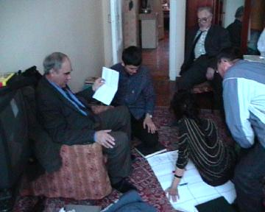
Fig 1: Illya Illich and other DARCA
It was very encouraging to see that the DARCA scientists already had plans to make their own follow up film. “We plan to use these methods to shoot another film with Illya Illich, about the significance of pastures for the Kazak population, their degradation, regeneration and the profits of their correct use.” (extract from Guliya’s written evaluation). A workshop was held to help them structure their ideas into a storyboard (below) and provide technical advice.
scientists plan their future film.

The new film plans to add detailed scientific arguments to the statements made by shepherds in the participatory video. In this way the perspectives of each group are strengthened and made more convincing by their association with the other.

Making this storyboard helped the scientists consolidate their vision of their new role in independent Kazakstan; working at the grassroots level (consulting with users, raising awareness), and directly influence policy/decision makers. The video project and DARCA’s activities generally, have helped them develop this vision and have equipped them with additional tools and skills that can be used to achieve these aims.

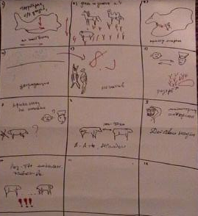  Fig 2: Storyboard of scientists planned film. | Scene 1: Map of Kazakstan, voice over; info on the territory and its pastures. | Scene 2: Shot of gd. pasture with animals grazing, voice over; the significance/role of pastures for K’s economic development. | Scene 3: Arrows on map showing traditional migrations.
 | Scene 4: Shepherds talking about degradation, shot’s of degraded land around villages, near wells etc. | Scene 5: negative effect of degradation on people +animals. (less profits) Shepherds and scientists speak. Show slaughtered thin sheep. | Scene 6: What are the solutions? How to improve? Shepherds and scientists speak.
 | Scene 7: Why good to migrate? shepherds and scientists explain | Scene 8: Discuss solution of small-scale migrations. Shepherds who are doing this talk about how to do it. | Scene 9: The task of scientists: Monitoring, biomass analysis, breeds– Nurlan’s work. The results they are getting.
 | Scene 10: Shots of scientists working with communities, and local authorities, using video: further task of sci. - to disseminate info, raise awareness, listen and exchange.
The results of our work with the institute of pasture and fodder have shown that participatory video approaches significantly enhance and compliment other forms of scientific research. The communities have been empowered and actively involved in the research. This has lead to better results, producing research that is directed by the real needs, capabilities and concerns of the local people. Video has been recognised by our colleagues as a powerful and effective tool for working with communities and for influencing policy/decision makers. In addition the video project has helped to highlight the main issues in the villages and reaffirm the importance and relevance of the research being carried out by the DARCA scientists.

Evaluations:
Aidos Smailov
Participatory video is an important means of working with people in the villages. It shows the real situation and makes it easier for people to express themselves. By using the camera and being involved, villagers also gain new knowledge and skills. It was useful to hear the people's ideas and plans for the future, we also learnt a lot from returning to show the film to the villagers and hearing their different reactions.

It is good that the film conveys useful and serious information whilst remaining entertaining; it doesn't make people feel bored. Policy makers also found it interesting and expressed a wish to use it in future conferences. Participatory video carries a message from the people to the officials, serving as a bridge for both sides.
These methods are also useful in my work as an English teacher at the university. I am currently helping students make a film about a poor lady who is trying to survive these hard times.

Gulia Khardebekova
I think that participatory video is a useful tool for our institute because it gave us the possibility to document many important scientific things such as the condition of pastures and the methods of their using by shepherds. It is a good way of working with villagers; the interactive shooting of the film allows us to learn more details about their life.

The finished film was useful in many aspects:
- villagers saw that if they want to, they can do something to improve their life.
- scientists heard the opinions of shepherds.
- officials saw that people were trying to solve their problems and had good ideas.

I think it would be good if the film was shown across the whole of Kazakhstan. It would be useful. Encouraging others to think about what they can do to improve their lives and making officials think about what they can do to help these people.

We plan to use these methods to shoot another film with Illya Illich (see above).

WORKING WITH THE COMMUNITY

The film was shown on many different occasions in Aidarly village. A number of community screenings were held at the school as well as some smaller group screenings held in various houses around the village. We also showed the film to a large group of villagers in neighbouring Sartokum village and to a group at one of the nearby roadside yurt-cafés along the Almaty-Astana road. In total approximately 150 villagers saw the film. Discussions and evaluations took place after each showing. A laptop enabled us to carry out any changes to the film recommended by villagers. The team all felt that we learnt a lot from showing the film and discussing our results with villagers and our understanding of their situation deepened considerably. On some occasions video evaluations were carried out, fragments of these are included below.

What did you think about the film - is it useful, why?
“This film is about people, their ideas and how to continue living together and it is very good. It is important that everything we said and presented has been fulfilled” Dauletbek Aidarly shepherd

“Everything that was said is possible to realise, the people must work together and the Akimat must support them as well” Aidarly school teacher

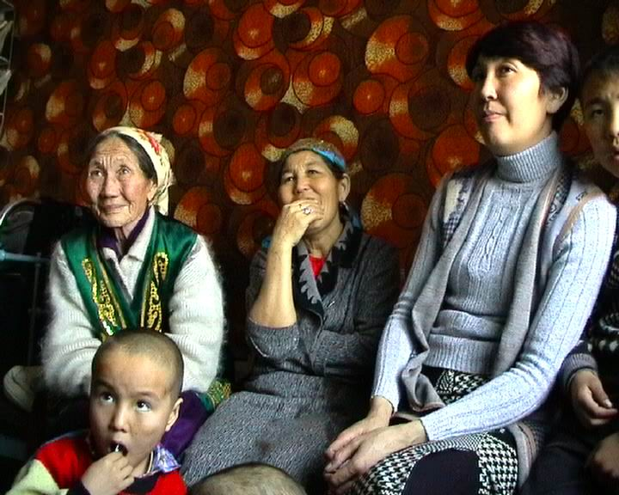
Fig 3; Four generations from the same family watch the film

“Honestly speaking, this film is great, I like it very much. Every word is true with no exaggerations. As for Zharkin he says very true words. It’s not easy to get land from the Akimat. It’s correct that we need a lawyer who would help us. It’s a good idea. I am very happy, because I like it very much!” Kalshengel, Aidarly shepherd from Mongolia

“Of course people quarrel about the land. They want to use pastures with water. Digging your own well is not so expensive; you may need to sell 1 horse. They don’t want to spend anything on it so they quarrel” Bahit, Aidarly shepherd

“I liked the problem with the land and keeping animals out of the village. This is an important problem and what they say is correct.” Neighbouring villager at roadside yurt-café

“It’s a very nice film, rich in content and it carries an educational message which is useful for the people.” Village elder, Aidarly
“The film helped me fulfil my plans, now my words have come back to me, I have evidence now, I have realised all the ideas I talked about!” Zharkin Aidarly shepherd featured in the film

“Janna has moved to Astana (capital city) and has set up a bakery with her Aunty. The film helped her strengthen her ideas and now she is trying to realise them.” Mother of Janna who made the film “Fresh ideas for Dairy products” see p. 4

Who do you think should see this film, why?
“Showing the film to villagers is best, you can show it to the regional Akim but they have no money nowadays, that’s why they aren’t able to solve anything” Kalshengel, Aidarly shepherd

“I don’t think there will be big changes if you show this film to the regional Akim or any other Akims. On the whole they don’t have power; in order to provide help they need money. They do not have anything. It is no use even if you show it to people in high positions. First it should be shown to the people. They will understand it and will adjust to the situation and find solutions. Of course officials should also see it. Maybe some of them do not know these problems.” Neighbouring villager

“It should be shown to people like us who work with livestock you should also show it to the whole country. It is a good exchange of experience. Young people will see it and will try to achieve the same and they will learn.” Aidarly shepherd

“Now the government doesn’t have any money to help anybody. The government itself hardly makes a living. The only way is for people to get together and help themselves” Neighbouring villager at yurt-café

How could the film be improved / what is missing? Any other comments.
“I think you should have dealt with some of our problems, but you didn’t touch on many of them” Aidarly Village elder

“The film is really good, I think it is made correctly, but I’d say it is too short and not everything is covered.” Zharkin, Aidarly shepherd

“In Sartokum they lack in water and they are forced to buy water for their animals. I think this is the result of neglect from the government. There is water in a nearby reservoir they should arrange for it to come to this village. Water is a big problem for all the villages around here; when spring comes people plant vegetables and water comes in the canal. Then suddenly it is cut off and all the crops die and people cry and beg the Akims, but it still doesn’t come. This should be included in your film.” Sartokum village resident.

“People should get together but not everyone can do that. Some have animals others do not. There are some families who cannot even provide their children with bread.” Sartokum village resident.

“The people today with animals are former bosses and shepherds with connections. They now have 100 or 50 sheep, but these are the leftovers of what they had before. The rest have been sold and gone into the bosses’ pockets. These are the ones still herding and now they are able to hire workers. People like us will be their hired shepherds.” Local unemployed man, Yurt-café

Problems with migration;
Whilst everybody agreed with the messages delivered in the film that joining together to facilitate migration was a useful strategy, some shepherds emphasised the difficulties of migrating and joining flocks. Bahit, who was one of the authors behind the film “returning to forgotten pastures”, had recently abandoned his partners. He suspected them of stealing his saddle. Lack of trust and honesty between partners is a very real obstacle to the success of some of these schemes. He had concluded that only relatives could successfully join their flocks. The shepherds lack alternative models and ways of organising these ventures and many fail. This theme is something that requires further discussion and focussed workshops with villagers to help them come up with alternative models and ideas.

“It’s difficult to join, there are some who can’t join or are simply not capable. I mean they are from different families so it is more complicated. Maybe these people need someone to tell them “join your friend and look after the animals together.” Yes, they need someone to organise this, otherwise it’s difficult.” Zharkin, Aidarly shepherd

“Of course it is effective and beneficial to join if you have about 50-60 sheep, but people with 150-200 sheep and goats can not join and herd together. The reason is there is not enough water and no big barns as there were in the past. It’s not easy to build a new barn” Kalshengel, Aidarly shepherd

“I say that migration is not an easy thing. This winter I am staying quite far from the village and every time I go there I use 20 litres of petrol. But I have a family and I think about their future that is why I do it properly” Kalshengel, Aidarly shepherd

Author’s evaluation/Lessons learnt:
When we visited neighbouring villages it was clear that many suffered much worse conditions than Aidarly. Even within Aidarly there are large groups of very poor unemployed people who are not represented in the film. To these groups the film is unable to offer any hope or solutions. Issues of degradation around the village are irrelevant as they often have no animals at all. These people are often so depressed that they refused to participate and feel unable to contribute anything to our workshops. More time is needed in order to reach these groups as their self esteem and confidence is so low (see recommendations for future work, p. 13).

The DARCA project was focussed on issues relating to degradation and was therefore limited in what it could cover. Other issues of equal or greater importance had to be sidelined (e.g. unemployment, problems of water supply for growing vegetables etc.) In addition local authorities and villagers made it clear from the beginning that they didn’t want to focus on the negative aspects of village life. As a result the film is slightly unbalanced and does not fully represent all the problems experienced in the villages. A more balanced film would have required greater resources, more time and a more flexible agenda. The resulting film would have given a fuller view of the problems and opportunities in the village and would have resonated with a greater spectrum of individuals in the villages. It would also have increased the films impact on local policy makers and donors.

As the above quotes show the film was well received by villagers. Many felt proud to see themselves and their neighbours in the film and it gave people a sense that the problems they are now facing can and will be overcome. The film served to weaken the mentality of hopelessness and dependency so common in villages across Central Asia. In my opinion this is an important step towards improving conditions in these areas.

Recommendation: Future projects should harness the full potential of participatory video as a tool for mobilising and disseminating positive social change. These methods allow us to explore research topics whilst simultaneously involving the community in a process of positive change. More time and resources should be allocated to this kind of work and boundaries between research and development should be removed.

WORKING WITH LOCAL POLICY MAKERS
(incomplete awaiting translations of video evaluations)

The film was shown at the regional centre to Mr .Chajabaev (Deputy Akim), Mr. Navakovsky (Head of land use committee) and Mr.Bekkojaev (head of agric. department). The Akim was unable to attend due to an unexpected summons to Almaty.

They enjoyed the film and a long discussion followed between our DARCA scientists and the officials. They felt that the film supported their own aims to encourage shepherds to migrate. They wanted a copy of the film to show at an upcoming meeting of all the regions’ heads of local administration.

DISSEMINATION AMONG DONOR AGENCIES

The film was shown to the following international donor agencies in Almaty; UNDP, OCSE (Organisation for Security and Co-operation in Europe), Israeli embassy MASHAV programme leaders, and the British Embassy. The meetings were all well attended and they welcomed the opportunity to hear about conditions in the rural areas from the people themselves; “gaining a broader understanding of the issues that face the poor and vulnerable is always helpful to a donor organization focused on poverty alleviation. Using visual media gives a stronger image of the issues of change facing pastoralists.” Jeremy Horner, Associate Professional Officer, DFID

DARCA’s leaflet was distributed and our aims and research was explained. Showing the video allowed us to acquaint them with the important issue of degradation in rural areas and also publicise the work being carried out by DARCA. They were also impressed with the way in which DARCA used participatory video as a means of involving the communities in the research;
“In my opinion involving the civil society in the process of film preparation helps to solve several goals at a time:
- to raise awareness of the population to the problems of this particular district;
- to involve the local population in the decision-making process by proposing alternative ways of problems solution;
- to stimulate the dialogue of the population with the local authorities; to break down the mentality of hopelessness
Madina Ibrasheva, expert on Economic and Ecological Affairs, OSCE

“One of its strengths was that it was able to tie together various different messages that arise in any given community and give a clear message that needed to be heard by the Akimat”. Jeremy Horner, DFID

They all requested copies of the film and expressed a desire to show it within their organisation.

The British Council were also given a copy for their library which is open to the general public. Chris Lunch wrote a press release which will be included in their monthly bulletin. This is available in Russian and English and is widely distributed throughout Kazakstan to International donors, regional Akimats (administrative centres), politicians, and International businesses:

PRESS RELEASE………FOR BRITISH COUNCIL’S MONTHLY BULLETIN

PARTICIPATORY VIDEO MAKES A CHANGE
A video made by villagers from a small shepherding community in Jambul rayon received an enthusiastic response from villagers, administrators and donor agencies last month. The film, which was directed and even filmed by villagers, presents the local people’s ideas and perspectives on important issues such as over grazing around villages, land privatisation and local ideas for increasing profits from livestock products.

This method of using video as a tool for working with communities is known as “participatory video”. It is being pioneered by the British firm Small World Action Projects (SWAP). Chris Lunch (director) explains “making a video together can unite a group and transcend boundaries of age, sex or wealth. It is an empowering and fun process which encourages the energy for change to come from within the community”.

The resulting film is original and inspiring. The national television channels Khabar and Kazakstan 1 were quick to get copies and will be showing it from March 2002. It has also proved to be a powerful tool for influencing other shepherding communities, local policy makers and donor organisations throughout Kazakstan. A Copy of the film can be viewed at the British council library, Almaty.

The film is part of an EU funded research project called “Desertification and regeneration in Central Asia” (DARCA). Scientists from 3 continents (including Kazakstan) are collaborating to study the environmental and economic impacts of agricultural reforms in the arid regions of Kazakstan and Turkmenistan. The DARCA project is coordinated by Dr Roy Behnke from Macaulay Land Use Research institute, UK. (Contact g.davidson@macauly.ac.uk).

The video project was carried out by SWAP. For comments or inquiries, or to obtain a copy of the film contact Chris Lunch at SWAP: clunch@hotmail.com

RECOMMENDATIONS FOR FUTURE WORK

(See Author’s evaluation/ Lessons learnt p11)

- Projects which focus on looking at ways to improve life for young people and increase their opportunities are desperately needed.

- The unemployed and those without any animals should be given the chance to improve their lives and build up flocks of their own. Lessons could be learnt from Turkmenistan’s successful arienda (leasing) system. Shepherds could be encouraged to pay hired helpers with lambs as part of their wages? Or a credit system could be introduced.

- Future work should look into the issue of providing a dependable supply of water for small-scale farming. This would provide opportunities for young people and the unemployed.

- Small scale migrations should be encouraged through the following activities:
a) Awareness-raising among villagers and local/national authorities about the problems and solutions of degradation (use existing film as a tool for workshops).
b) Improve water availability in quality pastures not too far from the villages
c) Explore different organisational structures for shepherds to cooperate (use participatory video to encourage an exchange of best practice among shepherds).
d) Provide clear legal advice to communities re. land laws. Lobby local and national government using video with the voices of shepherds, Akims and local scientists.

